ANSWER 4.1




ANSWER 4.2




ANSWER 4.3
A) The arrangement of optical cable types used in practice in increasing order according to their size:
The size of optical cables is typically categorized by the diameter of the core (the central part that carries the light). Here is a general arrangement from smallest to largest:
- Single-Mode Fiber (SMF):
  - Single-mode fiber has a small core size, usually around 9 microns in diameter. It allows only one mode of light to propagate, providing high bandwidth and long-distance transmission.
- Multimode Fiber (MMF):
  - Multimode fiber has a larger core size compared to single-mode fiber, typically around 50 to 62.5 microns in diameter. It allows multiple modes of light to propagate, providing shorter-distance transmission but with a higher bandwidth than single-mode fiber.
- Plastic Optical Fiber (POF):
  - Plastic optical fiber has a larger core size compared to glass fibers. The core size can vary but is generally in the range of 200 to 1000 microns. POF is often used for shorter-distance applications.
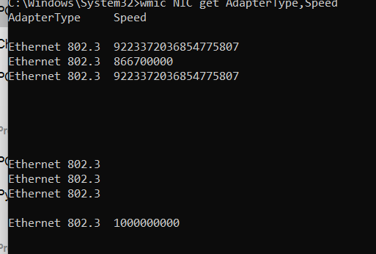
ANSWER 4.4

ANSWER 4.5
